**Proposed paper structure – preliminary version**

1. **Abstract**
   * **research interests**: Do international corporation (defined as multinational participation in same incident within the scope of this essay) yield positive benefit in terms of efficiency, why or **why not**.
   * Title maybe something like: *A business visualization Approach for effect of international cooperation on workflow efficiency: An Exploratory Case Study on the Volvo IT Incident Management Process*

*NEED TO CHANGE, copy and paste from the other Volvo essay

* + **methodology used**: business intelligence and visualization
  + **Summaries of findings & implication:** just some general implication i.e. provide insight on resource allocation and better corporation within the firm, could be something that firm can benefit if take undertook similar visualization case analysis like

i.e. instead of blindly handoff to Poland and Sweden, maybe can have more strategic handoff to specific country according to incident nature / impact level/ product

我知道这个part你可能没怎么做毕竟这个涉及company research,但是我觉得implication还是必要的，我们这个research有什么practical的implication么，毕竟咱一个focus是在商业可视化，我们得让公司门知道在这个process中能得到些什么。在abstract就几句话讲一下就OK

1. **Introduction**
   * Expand *international corporation*, talks about the its relative importance (why do we want to study it), then move on to research interest and properly define *international corporation* and other relevant definition *i.e. efficiency.*
   * Summary of what exactly have we done in this essay
     1. We use visualization find out international corporation not that fancy
     2. We factor out the reason and find out its due to country specific reason
     3. We did an country analysis on the big 8
   * Contribution of this essay:
     1. research field in terms of expand the understanding benefit or the conditional benefit of international corporation
     2. potential methodological contribution: business intelligence and visualization. Comparison between standard tabular data analysis and visualization, what is the benefit of the latter

我觉得可能要work on this part, it is easy to explain the benefit in a business perspective (businessmen don’t know statistic, graphs are way more easier to understand), but how to address it in the academia context, why should academia use visualization to do research? 还是我们其实不需要解释这个part？

1. literature review
   * Previous work on international corporation and how does that affect multinational company.
   * What part does previous literature cover, and what part they didn’t cover.
   * How is our focus different/ how can we shed light on this field
2. Data
   * Brief description on the data set we used, 此处参考 the other Volvo essay的data description
3. phenomenon & impact factor
   * 现象一： Higher level of international cooperation lead to higher efficiency trend, figure, but not so much practical benefit as blue dot typically lie below the other two dots, figure 2.

A close up of a map

Description generated with very high confidenceA close up of a map

Description generated with high confidence

#just a suggestion, change the x-axis of the second graph from number of log to number of workers? I think it’s more intuitive, plus, company maybe more interested in knowing how many worker work on each product relative to how many log.

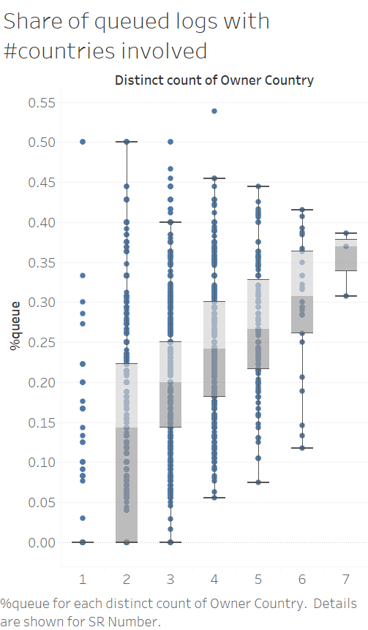

* + 现象二：When number of participation country increases, percentage of queued log increases

** can we draw this conclusion simply from eye balling the graph? Maybe we should use hypothesis test to test the difference in mean.

Also, is this statistically robust? The data point in high international cooperation is so small, prediction from this small sample valid?

* + 现象三： 或许可以看看duration per worker, 当participation country increase的时候，会不会每个worker spend在这个incidence 的 average duration变长之类的
  + 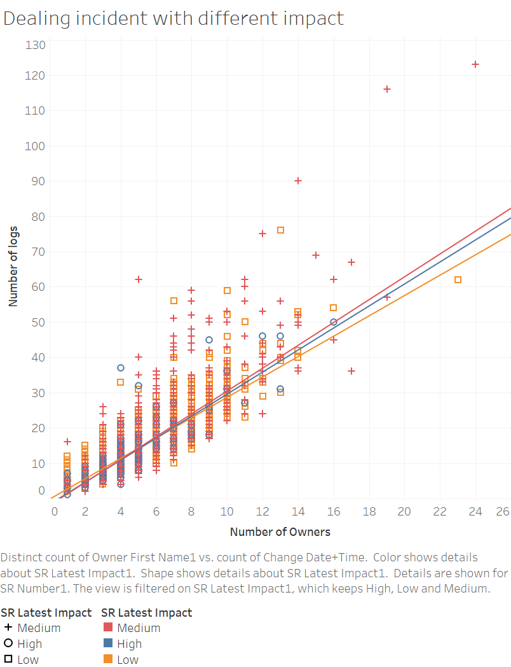impact factor 1: maybe higher cooperation usually happened on high impact which is more difficult to handle, thus drag down efficiency. NOT THE CASE, log per worker is similar across all three impact levels, no matter what kind of incident high cooperation usually dealt with, should not yield difference.
  + impact factor 2: maybe there is particular product that cause more incident per worker, and high cooperation usually dealt with these product? NOT THE CASE, given high number of involved worker (>20), the incident per worker is quite linear,which means there is no case where certain product has explosive amount of incident and then little worker work on them. 是这么理解的么，但是老个incident per worker 是怎么link到efficiency的啊，或者怎么link到international cooperation的， 嗯嗯 我怎么有点迷。
  + 这里你就自己写写吧，我要赶due去了，主要是后面有些图我看不懂gg

比如说这张图，这两张图排除了什么factor来着？

* + 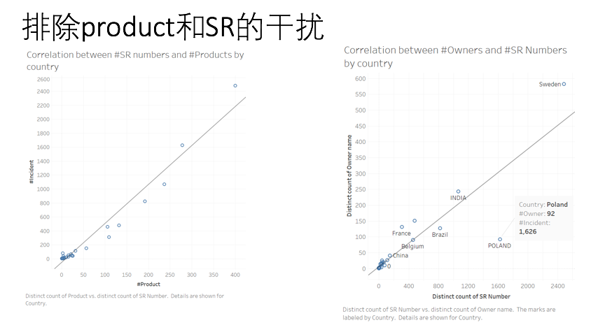

1. country specific reason, await additional research
2. result and discussion
3. reference